


Welcome to our Autumn Newsletter 2026 – We hope everyone is enjoying their return to Pre-School and all our new children have settled in well. Here are some activities planned over the next few weeks for your information:

TOPIC’S FOR THIS TERM

This term our Butterflies are covering ’The Gruffalo’ and our Caterpillars are concentrating on ‘ Elmer ’

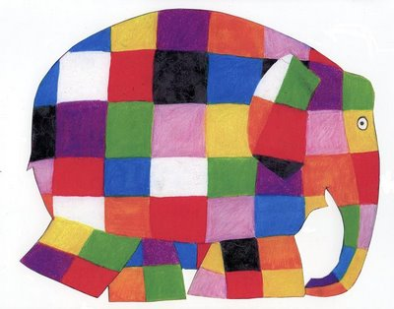
This Photo by Unknown Author is licensed under CC BY-SA-NC
This Photo by Unknown Author is licensed under CC BY-SA-NC

THURSDAY 22ND OCTOBER – PUMPKIN PARTY 

Children attending on this date can dress up for our party where will be offering pumpkin themed activities and snacks.

FRIDAY 13TH NOVEMBER – CHILDREN IN NEED



All children that attend on Friday’s are encouraged to dress up in spotty clothes and help us to raise money for this good cause with a donation.

FRIDAY 18TH DECEMBER -NATIVITY SERVICE 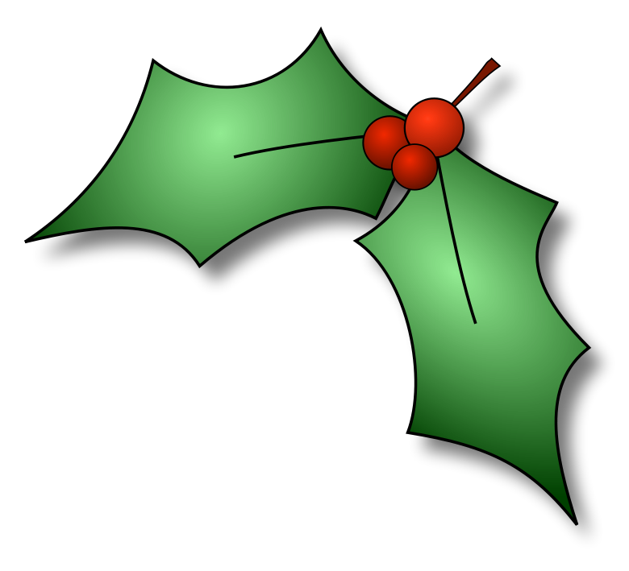

Butterfly Parents and carers we would like to invite you to our Christmas service at the Church with the time to be confirmed so we will provide more details later on.

TOTAL COMMUNICATION
As a whole setting we are encouraging all of the children to use total communication therefore you may have noticed
your child already practicing this at home more with their Please and Thank You’s

REMINDER
PLEASE CAN YOU MAKE SURE YOUR CHILD HAS AT LEAST 3 SPARE OUTFITS -SOCKS, TOPS & TROUSERS!
Please also provide a coat in preparation for the cold weather.

LUNCHBOXES
Polite reminder only 1 treat per lunchbox such as crisps or biscuit as ‘Offering children a wide range of foods, textures and flavour’s can help increase the variety of foods children will eat. This can encourage healthier eating habits later in childhood. This is especially important during this time of early growth and development ‘ quoted by the EYFS

FUNDING
If your child will be eligible for 15 or 30 Hours (that require a code) in the Winter Term (January 2026) please remember you will have to CLAIM and or RENEW your funding code by the 31st December 2026 and email this code to us straightaway if it is a new application. (This is very important as it cannot be backdated)

Please remember we are closed for an Inset Day on Friday 23rd October and we break up for Christmas on Friday 18th of December AT 2PM (Up to date Term Dates are always available on our website at the bottom of the Parent zone tab)

We hope you all have a great Autumn Term

From
Your Pre-School Team


